Winter Maintenance Plan Cover Sheet

Property Manager Name:
Name of Development:
Address of Development:

Date:
Watershed:
Winter Maintenance Management Plan Used: (basic/intermediate/detailed)

I will work to reduce salt use at this location to protect our natural resources.
Signed: _____________________

Intermediate Plan Criteria
All components of the basic plan + intermediate plan

Required information:
- Individual responsible for the winter maintenance at this site
  - Name
  - Phone number
  - Email
- MPCA Smart salting certificate of at least one person involved in winter maintenance operations at this site
  - Name
  - Company
  - Phone number
  - Email
  - Proof of Certificate

*MPCA list of certified applicators
*MPCA-approved salt training calendar

Permit issuer chooses from recommended fields:
Easy to verify:
  - X% of winter maintenance crew are MPCA Smart Salting certified
  - Subcontractors’ organizations are level 2 MPCA Smart Salting certified
Easy to observe:
  - No granular salt on surfaces after the event
  - Proper storage of granular deicers
  - Proper storage of liquid deicers
  - Proper storage of snow (not in waters of the state)
  - Educational signs on property (i.e. lower salt use and why, MPCA poster in lobby, MPCA window clings, Slippery area signs, It is winter: Walk carefully & drive carefully, Eco path no salt use area, How to use the salt bucket sign…)
*Proper liquid storage requirements
*Smart salting resources for applicators

Intermediate Plan Example
Property Manager Name: Julie Jones
Name of Development: Park N Ride West
Address of Development: 123 main street, Wayzata MN 55391
Date: 7/3/21
Watershed: Minnehaha Creek
Winter Maintenance Management Plan Used: Intermediate
I will work to reduce salt use at this location to protect our natural resources.
Signed: Julie Jones
Individual responsible for the winter maintenance at this site
  - Name: Joe Smith
  - Phone number: 688-876-3445
  - Email: Joes@gmail.com
Smart salting certificate of at least one person involved in winter maintenance operations at this site:
  - Name: Sarah Kinney
  - Company: FCI
  - Phone number: 123-321-1234
  - Email: Sarah@Fortinconsulting.com
  - Proof of Certificate: 4/5/21

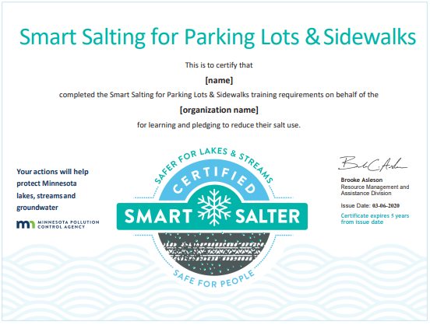

50% of winter maintenance crew are MPCA Smart Salting certified
10-person full time crew, 50% certified. More part time crew will be added during winter months and will work under the direction of the full-time crew. It is up to our subcontractors to train their own crew. We request that the subcontractors organization be level 2 certified as shown below.
Certified Crew and Date of Certification:
- Sarah Kinney, 4/5/2021
- Tom Johnson, 5/18/2021
- Maggie Halloway, 5/4/2021
- Trish Johnston, 5/7/2021
- Luis Lopez, 4/18/2021

Subcontractors’ organizations are level 2 MPCA Smart Salting certified
Certified subcontractors and Date of Certification:
    - Jose’s Snow and Ice, 5/6/21
    - Walleye Landscaping, 6/8/21
No granular salt on surfaces after the event
    - We will strive to use the right amount. However, if we’ve overapplied, we will recover the extra and use it at a different event.
Proper storage of granular deicers
  - Our granular deicers will be stored under a cover and on an impermeable surface.

Proper storage of liquid deicers
  - We do not use liquid deicers
Proper storage of snow (not in waters of the state)
  - Snow will not be pushed into wetland #215 or Plymouth Creek.
Educational signs on property
  - Educational signage about smart salting use will be posted for our tenants at entrances from November through March.

