Winter Maintenance Plan Cover Sheet

Property Manager Name:
Name of Development:
Address of Development:

Date:
Watershed:
Winter Maintenance Management Plan Used: (basic/intermediate/detailed)

I will work to reduce salt use at this location to protect our natural resources.
Signed: _____________________

Detailed Plan Criteria
All components of the basic and intermediate plans + detailed plan

Required information:
- Individual responsible for the winter maintenance at this site
  - Name
  - Phone number
  - Email
- MPCA Smart salting certificate of at least one person involved in winter maintenance operations at this site
  - Name
  - Company
  - Phone number
  - Email
  - Proof of Certificate

*MPCA list of certified applicators
*MPCA-approved salt training calendar

Choose from recommended fields:
Easy to verify:
  - X% of winter maintenance crew are MPCA Smart Salting certified
  - Subcontractors’ organizations are level 2 MPCA Smart Salting certified
Easy to observe:
  - No granular salt on surfaces after the event
  - Proper storage of granular deicers
  - Proper storage of liquid deicers
  - Proper storage of snow (not in waters of the state)
  - Educational signs on property

*Proper liquid storage requirements
*Smart salting resources for applicators

Choose from the recommended list:

- Documentation
  - Map or spreadsheet
    - Size of entire maintenance area
    - Estimated amount of deicer per pass*
    - Size of each maintenance area (i.e. main parking lot, front sidewalk…)
    - Level of service for each area
    - Estimated amount of deicer needed per pass for each area
- Annual report
    - Total deicer use (in lb/gal)
    - Challenges in reducing salt use
    - Successes in reducing salt use
    - Plans for smart salting next year

Choose from the list of best practices:

- Remove snow before applying deicer
  - Snow removal early and often to prevent compaction
  - Better and or more snow removal tools (brooms, segmented blades, blowers, underbody blades, shovels by salt bucket...)
- Measure pavement temperature and trend, use this information to guide deicer selection and application rates.
- Have available a variety of deicer/abrasive materials so you can select the product that will work best in the lowest commodity depending on the conditions.
  - If deicers are being use, they should include liquid deicers
- Improve salt bucket situation (educate users, provide alternatives like shovels and brooms, provide application rate guidance, restrict use, provide small scoops)
- Calibrate spreaders, put calibration card on spreaders.
  - Use equipment capable of spreading at low rates suggested in MPCA parking lot manual or work towards this goal as you acquire new equipment.
  - Create application rate charts so applicators can see calibration card, and application rate guidance and be able to choose most appropriate setting on their spreaders.
  - If your application rate charts are more than twice the rate of the MPCA Smart Salting application rate charts explain why this is necessary.
- Sweep up extra salt after events
- Hold post storm meetings or debrief with maintenance crew on what went well and how to continue to work toward smart salting goals.
- Educate building and grounds users on smart salting and the role they play with safe driving and walking practices.
- Close areas not needed in winter so there is less surface area to salt
- Consider areas where you might change level of service from bare pavement to not bare pavement. (Salted walking path to eco-path for dog walkers (no salt))
- Other

Detailed Plan Example
Property Manager Name: Julie Jones
Name of Development: Park N Ride West
Address of Development: 123 main street, Wayzata MN 55391
Date: 7/3/21
Watershed: Minnehaha Creek
Winter Maintenance Management Plan Used: Detailed
I will work to reduce salt use at this location to protect our natural resources.
Signed: Julie Jones
Individual responsible for the chloride management onsite:
  - Name: Joe Smith
  - Phone number: 688-876-3445
  - Email: Joes@gmail.com
Smart salting certificate of at least one person involved in winter maintenance operations at this site:
  - Name: Sarah Kinney
  - Company: FCI
  - Phone number: 123-321-1234
  - Email: Sarah@Fortinconsulting.com
  - Proof of Certificate: 4/5/21

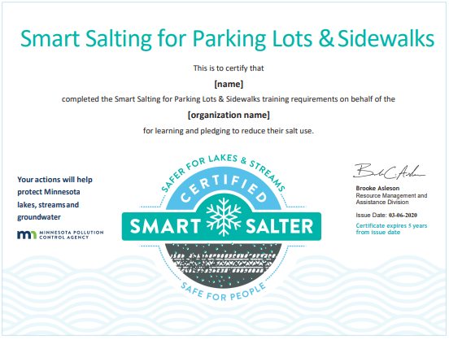

50% of winter maintenance crew are MPCA Smart Salting certified
  - 10-person full time crew, 50% certified. More part time crew will be added during winter months and will work under the direction of the full-time crew. It is up to our subcontractors to train their own crew. We request that the subcontractors organization be level 2 certified as shown below.
Certified Crew and Date of Certification:
- Sarah Kinney, 4/5/2021
- Tom Johnson, 5/18/2021
- Maggie Halloway, 5/4/2021
- Trish Johnston, 5/7/2021
- Luis Lopez, 4/18/2021
Subcontractors’ organizations are level 2 MPCA Smart Salting certified
Certified subcontractors and Date of Certification:
    - Jose’s Snow and Ice, 5/6/21
    - Walleye Landscaping, 6/8/21
No granular salt on surfaces after the event
    - We will strive to use the right amount. However, if we’ve overapplied, we will recover the extra and use it at a different event.
Proper storage of granular deicers
    - Our granular deicers will be stored under a cover and on an impermeable surface.
Proper storage of liquid deicers
    - We do not use liquid deicers
Proper storage of snow (not in waters of the state)
    - Snow will not be pushed into wetland #215 or Plymouth Creek.
Educational signs on property
    - Educational signage about smart salting use will be posted for our tenants at entrances from November through March.
Documentation
Map or spreadsheet
Size of entire maintenance area: 6,168 sq. Ft
Estimated amount of deicer per pass*: 25 lbs
*This is very close to the recommended rates in the MPCA Smart Salting for Parking Lots and Sidewalk manual.
Size of each maintenance area (i.e., main parking lot, front sidewalk…): (see map/spreadsheet)
Level of service for each area: (see map/spreadsheet)
Estimated amount of deicer needed per pass for each area: (see map/spreadsheet)

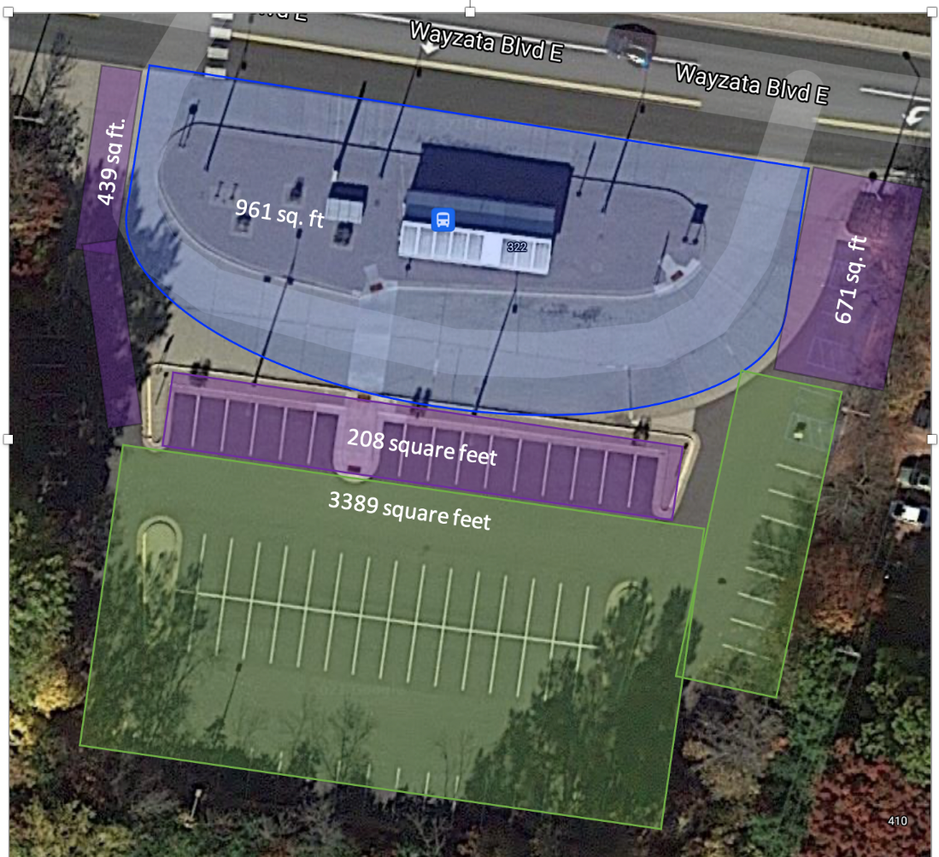
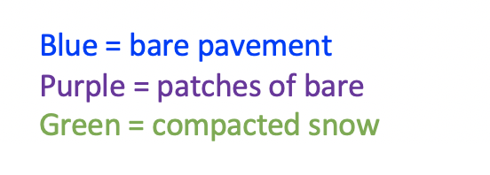
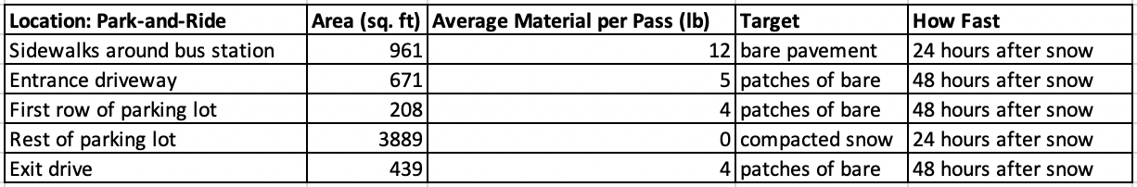
*Use abrasive if needed for traction on the compacted snow.

Annual report
Total deicer use (in lb/gal) per pass: 625 pounds
    - Salting Events: 25; 18 snow events, 5 freezing rain events, 2 melt and refreeze events
Challenges in reducing salt use
    - It is difficult to stay within the MPCA Smart Salting Guidelines. We really want to add more salt than that, we are trying it out as an experiment. Our maintenance crew changed throughout the season, so it was difficult to get them in a training class.
    - We had a big snow event, and a lot of users of park-and-ride complained that they wanted higher salt use.
Successes in reducing salt use
    - By the end of the season, most of the crew had at least one experience using liquid deicers.
Plans for smart salting next year
    - Next year, we will improve performance by using more liquid deicers.
    - We hope to do a better job of sticking to the level of service plans highlighted in our spreadsheet.

Best Practices:
Remove snow before applying deicer
Snow removal early and often to prevent compaction
      - We will remove snow before applying deicer. We will do our best do remove it early and often so that compaction doesn’t occur.
Better and or more snow removal tools (brooms, segmented blades, blowers, underbody blades, shovels by salt bucket...)
Measure pavement temperature and trend, use this information to guide deicer selection and application rates.
Have available a variety of deicer/abrasive materials so you can select the product that will work best in the lowest commodity depending on the conditions.
    - We will have more than one type of deicer available and choose the most effective one based on our pavement temperature and trend.
If deicers are being use, they should include liquid deicers
Improve salt bucket situation (educate users, provide alternatives like shovels and brooms, provide application rate guidance, restrict use, provide small scoops)
    - The salt bucket by the entrance to the park-and-ride booth will contain a very small scooper and a sign about why we want to reduce salt use. (“Chloride pollutes our waters. Please use salt sparingly.”)
Calibrate spreaders, put calibration card on spreaders.
    - We will calibrate our spreaders before the first snow.
Use equipment capable of spreading at low rates suggested in MPCA parking lot manual or work towards this goal as you acquire new equipment.
Create application rate charts so applicators can see calibration card, and application rate guidance and be able to choose most appropriate setting on their spreaders.
If your application rate charts are more than twice the rate of the MPCA Smart Salting application rate charts explain why this is n necessary.
Sweep up extra salt after events
Hold post storm meetings or debrief with maintenance crew on what went well and how to continue to work toward smart salting goals.
    - We will start conducting post-storm meetings, discussing the challenges and successes we had with salt use.
Educate building and grounds users on smart salting and the role they play with safe driving and walking practices.
    - We are going to educate the grounds crew and work staff at the Park-and-Ride about the lower salt use and why it is necessary. We will encourage them to walk and drive carefully to avoid falls/crashes.
Close areas not needed in winter so there is less surface area to salt
Consider areas where you might change level of service from bare pavement to not bare pavement. (Salted walking path to eco-path for dog walkers (no salt))
Other
    - We will speak about our efforts to reduce salt at the annual Minnesota Park-and-Ride meeting.

