BCWMC Watershed Plan Input Press Kit
Contents
City of Crystal Newsletter Article 2
City of Golden Valley Newsletter Article 3
City of Medicine Lake and AMLAC Newsletter Article 4
Minneapolis Neighborhoods and Communities Newsletter Article 5
City of Minnetonka Newsletter Article 6
City of New Hope & Friends of Northwood Lake Newsletter Article 7
City of Plymouth Newsletter Article 8
City of Robbinsdale Newsletter Article 9
City of St. Louis Park Newsletter Article 10
Flyer or Poster Half Sheet 11
Social Media Post 13
Survey QR Code 13
BCWMC Logo 13
Plan Update Website 13
Plan Process Graphic 14
Watershed Map 15
Watershed Photos 15

City of Crystal Newsletter Article
Bassett Creek Watershed Seeks Your Input and Insights on Lakes, Streams, Natural Areas
Did you know the North Branch of Bassett Creek runs through much of southern Crystal before flowing through Bassett Creek Park and converging with the Main Stem of Bassett Creek? What is your opinion of the creek? How often do you find yourself enjoying parks along the creek or sitting in a quiet area listening to the sounds of the water? Do you have ideas about how the creek or local lakes can be improved? The Bassett Creek Watershed Management Commission (BCWMC) is developing its 2025 – 2035 watershed management plan and is looking for your help and ideas!
The BCWMC would like to hear from neighborhood groups, community organizations, and residents about issues related to environmental and natural resource quality, especially those issues that affect the quality of streams, lakes, and natural areas. Your input will help us prioritize where to focus our attention, determine which areas need more work, and identify partners who can help.
There are many ways you can provide your thoughts and insights throughout this summer and fall! Take the online survey at www.surveymonkey.com/r/BCWMC-Public, request a presentation or information at an upcoming meeting or event, request a paper copy of the survey, and/or get on a mailing list to receive updates and information. Contact the BWCMC Administrator at laura.jester@keystonewaters.com or 952-270-1990; or complete the contact form: www.bassettcreekwmo.org/contact.
Public Survey QR Code

The Bassett Creek Watershed Management Commission is a local unit of government formed in 1969 to address flooding along Bassett Creek. It now also focuses on improving and protecting the water quality of lakes and streams throughout the watershed. The BCWMC is a joint powers organization among nine member cities: Crystal, Golden Valley, Medicine Lake, Minneapolis, Minnetonka, New Hope, Plymouth, Robbinsdale, and St. Louis Park and is governed by a Board of Commissioners with one commissioner appointed from each city. Funding for BCWMC programs and studies comes directly from cities while funding for large capital projects comes from property taxes levied by Hennepin County on behalf of the BCWMC. Learn more at www.bassettcreekwmo.org.

City of Golden Valley Newsletter Article
Bassett Creek Watershed Seeks Your Input and Insights on Lakes, Streams, Natural Areas
What is your opinion of Bassett Creek? How often do you find yourself enjoying parks along the creek or sitting in a quiet area listening to the sounds of the water? Do you have ideas about how Bassett Creek or local lakes can be improved? Are you worried about potential flooding? The Bassett Creek Watershed Management Commission (BCWMC) is developing its 2025 – 2035 watershed management plan and is looking for your help and ideas!
The BCWMC would like to hear from neighborhood groups, community organizations, and residents about issues related to environmental and natural resource quality, especially issues that affect the quality of streams and lakes, or concerns about flooding. Your input will help us prioritize where to focus our attention, determine which areas need more work, and identify partners who can help.
There are many ways you can provide your thoughts and insights throughout this summer and fall! Take the online survey at www.surveymonkey.com/r/BCWMC-Public, request a presentation or information at an upcoming meeting or event, request a paper copy of the survey, and/or get on a mailing list to receive updates and information. Contact the BWCMC Administrator at laura.jester@keystonewaters.com or 952-270-1990; or complete the contact form: www.bassettcreekwmo.org/contact.
Public Survey QR Code

The Bassett Creek Watershed Management Commission is a local unit of government formed in 1969 to address flooding along Bassett Creek. It now also focuses on improving and protecting the water quality of lakes and streams throughout the watershed. The BCWMC is a joint powers organization among nine member cities: Crystal, Golden Valley, Medicine Lake, Minneapolis, Minnetonka, New Hope, Plymouth, Robbinsdale, and St. Louis Park and is governed by a Board of Commissioners with one commissioner appointed from each city. Funding for BCWMC programs and studies comes directly from cities while funding for large capital projects comes from property taxes levied by Hennepin County on behalf of the BCWMC. Learn more at www.bassettcreekwmo.org.

City of Medicine Lake and AMLAC Newsletter Article
Bassett Creek Watershed Seeks Your Input and Insights on Lakes, Streams, Natural Areas
What is your opinion of Medicine Lake, Plymouth Creek or Bassett Creek? How often do you find yourself walking along the lake or creek, swimming in Medicine Lake, or sitting in a quiet area listening to the sounds of the water? Do you have ideas about how the lake or creeks can be improved? The Bassett Creek Watershed Management Commission (BCWMC) is developing its 2025 – 2035 watershed management plan and is looking for your help and ideas!
The BCWMC would like to hear from neighborhood groups, community organizations, and residents about issues related to environmental and natural resource quality, especially those issues that affect the quality of streams and lakes, or concerns about flooding. Your input will help us prioritize where to focus our attention, determine which areas need more work, and identify partners who can help.
There are many ways you can provide your thoughts and insights throughout this summer and fall! Take the online survey at www.surveymonkey.com/r/BCWMC-Public, request a presentation or information at an upcoming meeting or event, request a paper copy of the survey, and/or get on a mailing list to receive updates and information. Contact the BWCMC Administrator at laura.jester@keystonewaters.com or 952-270-1990; or complete the contact form: www.bassettcreekwmo.org/contact.
Public Survey QR Code

The Bassett Creek Watershed Management Commission is a local unit of government formed in 1969 to address flooding along Bassett Creek. It now also focuses on improving and protecting the water quality of lakes and streams throughout the watershed. The BCWMC is a joint powers organization among nine member cities: Crystal, Golden Valley, Medicine Lake, Minneapolis, Minnetonka, New Hope, Plymouth, Robbinsdale, and St. Louis Park and is governed by a Board of Commissioners with one commissioner appointed from each city. Funding for BCWMC programs and studies comes directly from cities while funding for large capital projects comes from property taxes levied by Hennepin County on behalf of the BCWMC. Learn more at www.bassettcreekwmo.org.

Minneapolis Neighborhoods and Communities Newsletter Article
Bassett Creek Watershed Seeks Your Input and Insights on Lakes, Streams, Natural Areas
What is your opinion of Bassett Creek? How often do you find yourself walking besides the creek, swimming at Wirth Beach, or sitting in a quiet area listening to the sounds of the water? Do you have ideas about how the creek can be improved or are you concerned about flooding? The Bassett Creek Watershed Management Commission (BCWMC) is working to improve the creek and is looking for your help and ideas!
The BCWMC would like to hear from neighborhood groups, community organizations, and residents about issues related to environmental and natural resource quality, especially those issues that affect the quality of streams and lakes, and concerns about flooding. Your input will help us prioritize where to focus our attention, determine which areas need more work, and identify partners who can help.
There are many ways you can provide your thoughts and insights throughout this summer and fall! Take the online survey at www.surveymonkey.com/r/BCWMC-Public, request a presentation or information at an upcoming meeting or event, request a paper copy of the survey, and/or get on a mailing list to receive updates and information. Contact the BWCMC Administrator at laura.jester@keystonewaters.com or 952-270-1990; or complete the contact form: www.bassettcreekwmo.org/contact.
Public Survey QR Code

The Bassett Creek Watershed Management Commission is a local unit of government formed in 1969 to address flooding along Bassett Creek. It now also focuses on improving and protecting the water quality of lakes and streams throughout the watershed. The BCWMC is a joint powers organization among nine member cities: Crystal, Golden Valley, Medicine Lake, Minneapolis, Minnetonka, New Hope, Plymouth, Robbinsdale, and St. Louis Park and is governed by a Board of Commissioners with one commissioner appointed from each city. Funding for BCWMC programs and studies comes directly from cities while funding for large capital projects comes from property taxes levied by Hennepin County on behalf of the BCWMC. Learn more at www.bassettcreekwmo.org.

City of Minnetonka Newsletter Article
Bassett Creek Watershed Seeks Your Input and Insights on Lakes, Streams, Natural Areas
While most of Minnetonka lies in the watershed of Lake Minnetonka and Minnehaha Creek, did you know some areas in northern Minnetonka, like Ridgedale Center and Crane Lake to its east, eventually drain to Medicine Lake in Plymouth and then into Bassett Creek? That’s the same creek that winds through Theodore Wirth Park in Minneapolis! What is your opinion about the lakes and streams in those areas? Do you have ideas about how the creek or local lakes can be improved? The Bassett Creek Watershed Management Commission (BCWMC) is developing its 2025 – 2035 watershed management plan and is looking for your help and ideas!
The BCWMC would like to hear from neighborhood groups, community organizations, and residents about issues related to environmental and natural resource quality, especially those issues that affect the quality of streams, lakes, and natural areas. Your input will help us prioritize where to focus our attention, determine which areas need more work, and identify partners who can help.
There are many ways you can provide your thoughts and insights throughout this summer and fall! Take the online survey at www.surveymonkey.com/r/BCWMC-Public, request a presentation or information at an upcoming meeting or event, request a paper copy of the survey, and/or get on a mailing list to receive updates and information. Contact the BWCMC Administrator at laura.jester@keystonewaters.com or 952-270-1990; or complete the contact form: www.bassettcreekwmo.org/contact.
Public Survey QR Code
The Bassett Creek Watershed Management Commission is a local unit of government formed in 1969 to address flooding along Bassett Creek. It now also focuses on improving and protecting the water quality of lakes and streams throughout the watershed. The BCWMC is a joint powers organization among nine member cities: Crystal, Golden Valley, Medicine Lake, Minneapolis, Minnetonka, New Hope, Plymouth, Robbinsdale, and St. Louis Park and is governed by a Board of Commissioners with one commissioner appointed from each city. Funding for BCWMC programs and studies comes directly from cities while funding for large capital projects comes from property taxes levied by Hennepin County on behalf of the BCWMC. Learn more at www.bassettcreekwmo.org.

City of New Hope & Friends of Northwood Lake Newsletter Article
Bassett Creek Watershed Seeks Your Input and Insights on Lakes, Streams, Natural Areas
Did you know the North Branch of Bassett Creek runs through Northwood Lake and downstream through much of southern New Hope? What is your opinion of the creek and Northwood Lake? How often do you find yourself enjoying parks along the creek or sitting in a quiet area listening to the sounds of the water? Do you have ideas about how the creek or local lakes can be improved? The Bassett Creek Watershed Management Commission (BCWMC) is developing its 2025 – 2035 watershed management plan and is looking for your help and ideas!
The BCWMC would like to hear from neighborhood groups, community organizations, and residents about issues related to environmental and natural resource quality, especially those issues that affect the quality of streams, lakes, and natural areas. Your input will help us prioritize where to focus our attention, determine which areas need more work, and identify partners who can help.
There are many ways you can provide your thoughts and insights throughout this summer and fall! Take the online survey at www.surveymonkey.com/r/BCWMC-Public, request a presentation or information at an upcoming meeting or event, request a paper copy of the survey, and/or get on a mailing list to receive updates and information. Contact the BWCMC Administrator at laura.jester@keystonewaters.com or 952-270-1990; or complete the contact form: www.bassettcreekwmo.org/contact.
Public Survey QR Code

The Bassett Creek Watershed Management Commission is a local unit of government formed in 1969 to address flooding along Bassett Creek. It now also focuses on improving and protecting the water quality of lakes and streams throughout the watershed. The BCWMC is a joint powers organization among nine member cities: Crystal, Golden Valley, Medicine Lake, Minneapolis, Minnetonka, New Hope, Plymouth, Robbinsdale, and St. Louis Park and is governed by a Board of Commissioners with one commissioner appointed from each city. Funding for BCWMC programs and studies comes directly from cities while funding for large capital projects comes from property taxes levied by Hennepin County on behalf of the BCWMC. Learn more at www.bassettcreekwmo.org.

City of Plymouth Newsletter Article
Bassett Creek Watershed Seeks Your Input and Insights on Lakes, Streams, Natural Areas
What is your opinion of Plymouth Creek? How about a lake near you like Medicine, Lost, or Parkers Lakes? How often do you find yourself walking along creek, swimming at a local beach, or sitting in a quiet area listening to the sounds of the water? Do you have ideas about how the creek or lakes can be improved or are you concerned about flooding? The Bassett Creek Watershed Management Commission (BCWMC) is developing its 2025 – 2035 watershed management plan and is looking for your help and ideas!
The BCWMC would like to hear from neighborhood groups, community organizations, and residents about issues related to environmental and natural resource quality, especially those issues that affect the quality of streams and lakes, and concerns about flooding. Your input will help us prioritize where to focus our attention, determine which areas need more work, and identify partners who can help.
There are many ways you can provide your thoughts and insights throughout this summer and fall! Take the online survey at www.surveymonkey.com/r/BCWMC-Public, request a presentation or information at an upcoming meeting or event, request a paper copy of the survey, and/or get on a mailing list to receive updates and information. Contact the BWCMC Administrator at laura.jester@keystonewaters.com or 952-270-1990; or complete the contact form: www.bassettcreekwmo.org/contact.
Public Survey QR Code

The Bassett Creek Watershed Management Commission is a local unit of government formed in 1969 to address flooding along Bassett Creek. It now also focuses on improving and protecting the water quality of lakes and streams throughout the watershed. The BCWMC is a joint powers organization among nine member cities: Crystal, Golden Valley, Medicine Lake, Minneapolis, Minnetonka, New Hope, Plymouth, Robbinsdale, and St. Louis Park and is governed by a Board of Commissioners with one commissioner appointed from each city. Funding for BCWMC programs and studies comes directly from cities while funding for large capital projects comes from property taxes levied by Hennepin County on behalf of the BCWMC. Learn more at www.bassettcreekwmo.org.

City of Robbinsdale Newsletter Article
Bassett Creek Watershed Seeks Your Input and Insights on Lakes, Streams, Natural Areas
Did you know some areas in southern Robbinsdale drain south through Sochacki Park into Bassett Creek? That’s the same creek that winds through Theodore Wirth Park in Golden Valley and Minneapolis! What is your opinion about Westwood Lake and the streams in that area? Do you have ideas about how the lake or creek can be improved? The Bassett Creek Watershed Management Commission (BCWMC) is developing its 2025 – 2035 watershed management plan and is looking for your help and ideas!
The BCWMC would like to hear from neighborhood groups, community organizations, and residents about issues related to environmental and natural resource quality, especially those issues that affect the quality of streams, lakes, and natural areas. Your input will help us prioritize where to focus our attention, determine which areas need more work, and identify partners who can help.
There are many ways you can provide your thoughts and insights throughout this summer and fall! Take the online survey at www.surveymonkey.com/r/BCWMC-Public, request a presentation or information at an upcoming meeting or event, request a paper copy of the survey, and/or get on a mailing list to receive updates and information. Contact the BWCMC Administrator at laura.jester@keystonewaters.com or 952-270-1990; or complete the contact form: www.bassettcreekwmo.org/contact.
Public Survey QR Code

The Bassett Creek Watershed Management Commission is a local unit of government formed in 1969 to address flooding along Bassett Creek. It now also focuses on improving and protecting the water quality of lakes and streams throughout the watershed. The BCWMC is a joint powers organization among nine member cities: Crystal, Golden Valley, Medicine Lake, Minneapolis, Minnetonka, New Hope, Plymouth, Robbinsdale, and St. Louis Park and is governed by a Board of Commissioners with one commissioner appointed from each city. Funding for BCWMC programs and studies comes directly from cities while funding for large capital projects comes from property taxes levied by Hennepin County on behalf of the BCWMC. Learn more at www.bassettcreekwmo.org.

City of St. Louis Park Newsletter Article
Bassett Creek Watershed Seeks Your Input and Insights on Lakes, Streams, Natural Areas
While most of St. Louis Park lies within the Minnehaha Creek Watershed, did you know some areas in northern St. Louis Park, like the Westwood Hills Nature Center, drain to the north and into Bassett Creek? That’s the same creek that winds through Theodore Wirth Park in Minneapolis! What is your opinion about Westwood Lake and the streams in that area? Do you have ideas about how the lake or creek can be improved? The Bassett Creek Watershed Management Commission (BCWMC) is developing its 2025 – 2035 watershed management plan and is looking for your help and ideas!
The BCWMC would like to hear from neighborhood groups, community organizations, and residents about issues related to environmental and natural resource quality, especially those issues that affect the quality of streams, lakes, and natural areas. Your input will help us prioritize where to focus our attention, determine which areas need more work, and identify partners who can help.
There are many ways you can provide your thoughts and insights throughout this summer and fall! Take the online survey at www.surveymonkey.com/r/BCWMC-Public, request a presentation or information at an upcoming meeting or event, request a paper copy of the survey, and/or get on a mailing list to receive updates and information. Contact the BWCMC Administrator at laura.jester@keystonewaters.com or 952-270-1990; or complete the contact form: www.bassettcreekwmo.org/contact.
Public Survey QR Code

The Bassett Creek Watershed Management Commission is a local unit of government formed in 1969 to address flooding along Bassett Creek. It now also focuses on improving and protecting the water quality of lakes and streams throughout the watershed. The BCWMC is a joint powers organization among nine member cities: Crystal, Golden Valley, Medicine Lake, Minneapolis, Minnetonka, New Hope, Plymouth, Robbinsdale, and St. Louis Park and is governed by a Board of Commissioners with one commissioner appointed from each city. Funding for BCWMC programs and studies comes directly from cities while funding for large capital projects comes from property taxes levied by Hennepin County on behalf of the BCWMC. Learn more at www.bassettcreekwmo.org.

Flyer or Poster Half Sheet

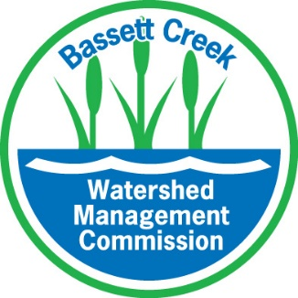
TAKE THE SURVEY
ABOUT LAKES & STREAMS IN YOUR COMMUNITY
The Bassett Creek Watershed Management Commission is developing its 2025 – 2035 Watershed Management Plan and is looking for your help and ideas! Take the survey to tell us about issues regarding lakes, streams, and natural areas important to you. Your input will help us prioritize where to focus our attention, determine which areas need more work, and identify partners who can help. Visit www.bassettcreekwmo.org for more information.
TAKE THE SURVEY
ABOUT LAKES & STREAMS IN YOUR COMMUNITY
The Bassett Creek Watershed Management Commission is developing its 2025 – 2035 Watershed Management Plan and is looking for your help and ideas! Take the survey to tell us about issues regarding lakes, streams, and natural areas important to you. Your input will help us prioritize where to focus our attention, determine which areas need more work, and identify partners who can help. Visit www.bassettcreekwmo.org for more information.

Social Media Post

BCWMC Plan Input Survey

Do you enjoy lakes and streams in your community? What do you like about these resources? What challenges should be addressed when planning to protect and improve lakes and streams? The Bassett Creek Watershed Management Commission seeks your input to help prioritize its work over the next ten years. Take the survey at www.surveymonkey.com/r/BCWMC-Public or learn more at www.bassettcreekwmo.org.

Survey QR Code

BCWMC Logo

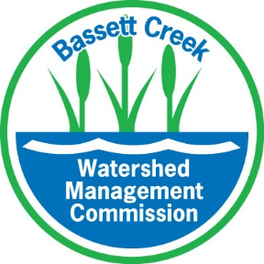

Plan Update Website

https://www.bassettcreekwmo.org/document/2025-plan-update

Plan Update Process Graphic

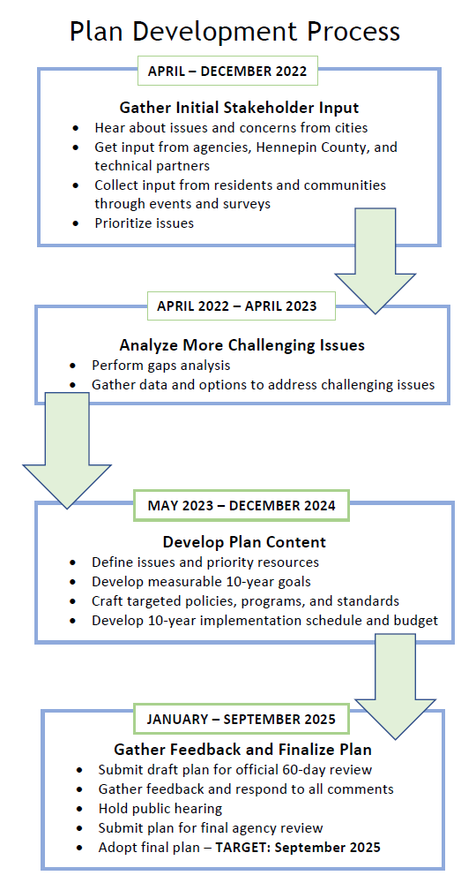

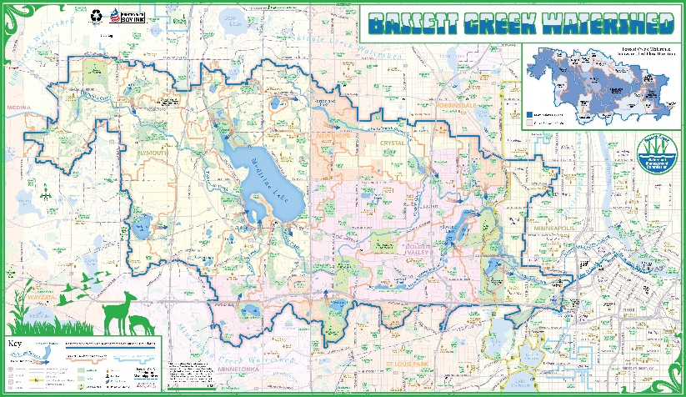
Watershed Map

Online interactive map:
https://www.bassettcreekwmo.org/lakes-streams
Photo of printed map (left)

Watershed Photos
Top left: Bassett Creek Restoration Site in Briarwood Nature Area, Golden Valley
Top right: Medicine Lake from West Medicine Lake Park
Bottom left: Wirth Lake
Bottom right: Sweeney Branch as it enters Schaper Pond
